Journal for Android – Installation Guide
Journal is currently being reviewed by Google and is not yet available on the Google Play Store.
Because the app is installed directly, Android and Google will display a few security prompts during installation. These are expected.

Before You Begin
- Android phone with internet
- About 100 MB free storage
- Google account (optional, for Drive backup)

Download Journal
Download the latest APK:
https://github.com/bobtheman/Journal/raw/main/Journal/Releases/Latest

Step 1 – Install the App
Tap Install.
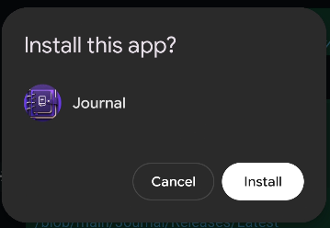
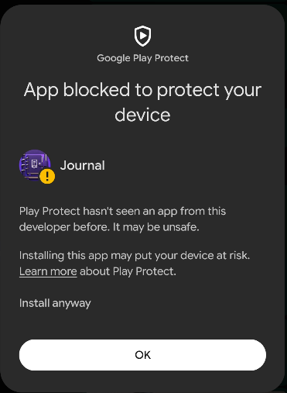
If Play Protect warns it can't verify the app, tap More details (if shown) then Install anyway. Tap Open when finished.

Step 2 – Create Your Journal Account
Create a local username and password, then optionally enable Fingerprint Unlock.

Step 3 – Enable Google Drive Backup (Optional)
Open Settings > Sign in with Google. If Google says 'Google hasn't verified this app', tap Continue. Your Google account must first be added as a tester.

Step 4 – Update Journal
Settings > App Update > Check for Updates. Download, allow installs from this source if prompted, then Update and Install.

Troubleshooting
Problem | Solution
App not installed | Remove any previous version and try again.
Play Protect blocks installation | Tap More details then Install anyway.
Google sign-in fails | Ask the app owner to add your Gmail address as a tester.
Can't find APK | Check Downloads or notifications.

You're All Set!
Journal is currently distributed directly while it completes Google's Play Store review. The extra security prompts are normal.

